**MANAV RACHNA UNIVERSITY, FARIDABAD**

**Department of Computer Science and Technology**

# Course: B.Tech. CSE Semester: III

**Subject: Object Oriented Programming using Java (CSH201B-T&P)**

***Lab: 06*** *Use of static and this keyword in Java*

***Objective:*** *Programs on static and this keyword in Java.*

***Course Outcomes:***

**CSH201B.1:** To impart **understanding** of basic programming concepts in Java language.

**CSH201B.2:** To enable the student to articulate given program scenario and **apply** different programming constructs.

***Blooms Taxonomy Level****: BT1, BT2, BT3*

Q1. WAP in java to define a class MyNumber having one private int data member. Write a default constructor to initialize it to 0 and another constructor to initialize it to a value (Use this for initialization). Write methods isNegative(), isPositive(), isZero(), isOdd(), isEven(). Create an object in main(). Use Scanner class to pass a value to the object.

package Point.java;

import java.util.Scanner;

public class MyNumber {

private int number;

public MyNumber() {

this.number = 0;

}

public MyNumber(int number) {

this.number = number;

}

public boolean isNegative() {

return number < 0;

}

public boolean isPositive() {

return number > 0;

}

public boolean isZero() {

return number == 0;

}

public boolean isOdd() {

return number % 2 != 0;

}

public boolean isEven() {

return number % 2 == 0;

}

public static void main(String[] args) {

Scanner scanner = new Scanner(System.in);

System.out.print("Enter a number: ");

int input = scanner.nextInt();

MyNumber myNumber = new MyNumber(input);

System.out.println("Is negative? " + myNumber.isNegative());

System.out.println("Is positive? " + myNumber.isPositive());

System.out.println("Is zero? " + myNumber.isZero());

System.out.println("Is odd? " + myNumber.isOdd());

System.out.println("Is even? " + myNumber.isEven());

}

}

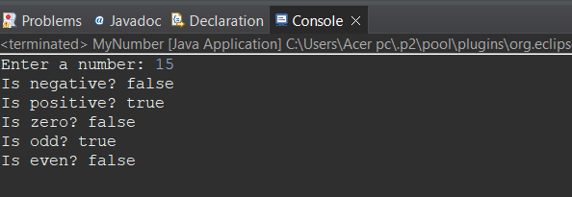

Q2. Define a Student class (roll number, name, percentage). Define a default and parameterized constructor. Override the toString method. Keep a count of objects created.

Create objects using parameterized constructor and display the object count after each object is created. (Use static member and method). Also display the contents of each object.

package Point.java;

public class Student {

private int rollNumber;

private String name;

private double percentage;

private static int count = 0;

public Student() {

this.rollNumber = 0;

this.name = "";

this.percentage = 0.0;

count++;

}

public Student(int rollNumber, String name, double percentage) {

this.rollNumber = rollNumber;

this.name = name;

this.percentage = percentage;

count++;

}

@Override

public String toString() {

return "Roll Number: " + rollNumber + "\nName: " + name + "\nPercentage: " + percentage;

}

public static int getCount() {

return count;

}

public static void main(String[] args) {

Student s1 = new Student();

System.out.println("Number of objects created: " + Student.getCount());

Student s2 = new Student(1, "Aman", 85.5);

System.out.println(s2);

System.out.println("Number of objects created: " + Student.getCount());

Student s3 = new Student(2, "Rohan", 92.3);

System.out.println(s3);

System.out.println("Number of objects created: " + Student.getCount());

}

}

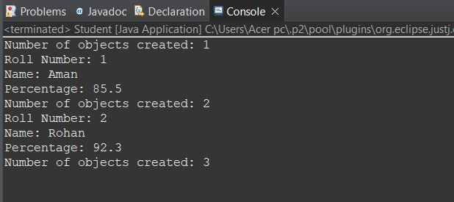

Q3. Implement the following Box

-Width: double

-Height: double

-Depth: double

+Box(double,double,double)

+Volume():double

Write a class TestBox that will contain main method. Create two objects of Box namely box1 and box2 having values 10,20,30 and 5,8,9 respectively for width height and depth. Calculate the volume and print on console.

package Point.java;

public class Box {

private double width;

private double height;

private double depth;

public Box(double width, double height, double depth) {

this.width = width;

this.height = height;

this.depth = depth;

}

public double Volume() {

return width * height * depth;

}

}

package Point.java;

public class TestBox {

public static void main(String[] args) {

Box box1 = new Box(10, 20, 30);

Box box2 = new Box(5, 8, 9);

System.out.println("Volume of box1: " + box1.Volume());

System.out.println("Volume of box2: " + box2.Volume());

}

}

